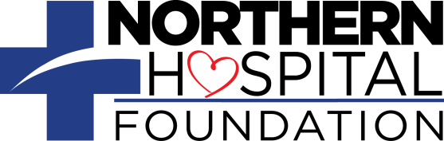
MY GIFT TO THE NORTHERN HOSPITAL FOUNDATION

Please print and mail to:
Matt Linville, Director
The Northern Hospital Foundation
Post Office Box 1101
Mount Airy, NC 27030
Office: 336.783.8484

Name ______________________________________________________

Address ______________________________________________________

City ________________ State ______ Zip _______ Phone (___) ____-______

Email _______________________________________________________

☐ Please find enclosed check made payable to The Northern Hospital Foundation for:

☐ $25 ☐ $50 ☐ $100 ☐ $250 ☐ Other $ __________

☐ Please bill my credit card for:

☐ $25 ☐ $50 ☐ $100 ☐ $250 ☐ Other $ __________

Card Number ____________________ Exp. Date __/__ Card Security Code _____

Name on Credit Card _______________________________________________

Phone (___) ____-______

☐ I am a Grateful Patient

Name of the caregiver or department you wish to honor: _________________________
Comments:___________________________________________________________________________________________________________________________________________________________________________________________
(We will notify the caregiver of your honor gift, but not the amount.)

☐ This gift is ☐ In Memory or ☐ In Honor of:

Name of person, family or organization: _____________________________________
Address ___________________________________________________________
City _______________________ State _____ Zip _______ Phone (___) ____-_____
(We will notify the person, family or organization of your gift, but not the amount.)

